Section 1: Case Summary

Scenario Title: | PEA Arrest and Breaking Bad News
Keywords: | Breaking bad news, Termination of resuscitation, Cardiac arrest
Brief Description of Case: | A 70 year old man who had an unwitnessed cardiac arrest is brought to the ED via EMS from his Tennis Club. Despite multiple rounds of appropriate resuscitative measures, the patient does not gain return of spontaneous circulation (ROSC). Learners will need to discuss the termination of resuscitation with team members and communicate with the patient’s wife.

Goals and Objectives
Educational Goal: | Expose learners to decision-making in termination of resuscitation and the delivery of bad news to family members.
Objectives:  (Medical and CRM) | - Demonstrate appropriate management of a PEA arrest/Asystole  - Recognize when further resuscitation efforts are futile and terminate further resuscitative efforts  - Communicate clearly with the team during a cardiac arrest  - Communicate with family in a compassionate and effective way about the death of the patient
EPAs Assessed: | C1: Resuscitating and coordinating care for critically ill patients  P3: Managing complex interpersonal interactions that arise during the course of patient care

Learners, Setting and Personnel
Target Learners: | ☒ Junior Learners |  | ☒ Senior Learners |  |  | ☐ Staff
 | ☐ Physicians | ☐ Nurses |  | ☐ RTs | ☐ Inter-professional
 | ☐ Other Learners:
Location: | ☒ Sim Lab |  | ☐ In Situ |  |  | ☐ Other:
Recommended Number of Facilitators: | Instructors: 1
 | Confederates: 2 (1-2 as BLS crew, 1 as patient’s wife; can alternatively be done on speaker phone by one of the facilitators)
 | Sim Techs: 1

Scenario Development
Date of Development: | 21/10/2013
Scenario Developer(s): | Dr. Alexandra Stefan
Affiliations/Institutions(s): | University of Toronto
Contact E-mail: | alexandra.stefan@utoronto.ca
Last Revision Date: | 10/03/2020
Revised By: | Kathryn Chan, Chris Heyd
Version Number: | 3

Section 2A: Initial Patient Information

- Patient Chart
Patient Name: John Grey |  |  |  | Age: 70 | Gender: M | Weight: 70kg
Presenting complaint: Cardiac Arrest PEA
Temp: 36.5C | HR: 45 | BP: none |  | RR: none | O₂Sat: none | FiO₂: 100% BVM
Cap glucose: 6.5 mmol/L |  |  |  | GCS: 3 (E1 V1 M1 ) unresponsive, fixed pupils 5mm
Triage note: Patient found vital signs absent (VSA) in change room of tennis club. Bystander CPR was initiated post 911 call, but down time is unclear. BLS crew arrived on scene, continued CPR and transported to the ED. There have been five ‘no shock advised’ for a total transport time of 10 min. The patient arrives in the ED with BVM, CPR in progress. No IV established. No pulse.
Allergies: Not available
Past Medical History:  Unknown |  |  | Current Medications:  Multiple medications, but not found on the person and no prior charts available

Section 2B: Extra Patient Information

A. Further History
Include any relevant history not included in triage note above. What information will only be given to learners if they ask? Who will provide this information (mannequin’s voice, confederate, SP, etc.)?

Married to wife Sarah for 40 years
B. Physical Exam
List any pertinent positive and negative findings
Cardio: No pulse, wide complex rhythm on monitors | Neuro: GCS 3
Resp: Not breathing | Head & Neck: No trauma
Abdo: No bruising or signs of bleeding | MSK/skin: Warm skin
Other: No signs of trauma

Section 3: Technical Requirements/Room Vision

A. Patient
☒ Mannequin – Adult male
☐ Standardized Patient
☐ Task Trainer
☐ Hybrid
B. Special Equipment Required
Defibrillator | IV Push ACLS Medications | Bag Valve Mask
Laryngoscope  Capnography | ET Tubes | Bedside ultrasound
C. Required Medications
Prefilled crash cart syringes (epinephrine, bicarb etc)

D. Moulage
Adult mannequin with CPR ongoing, supportive breaths provided by EMS via BVM

E. Monitors at Case Onset
☐ Patient on monitor with vitals displayed
☒ Patient not yet on monitor
F. Patient Reactions and Exam
Include any relevant physical exam findings that require mannequin programming or cues from patient
(e.g. – abnormal breath sounds, moaning when RUQ palpated, etc.) May be helpful to frame in ABCDE format.

At simulation onset CPR is ongoing by BLS crew
Pt remains VSA (pulseless) during entire case

Section 4: Confederates and Standardized Patients

Confederate and Standardized Patient Roles and Scripts
Role | Description of role, expected behavior, and key moments to intervene/prompt learners. Include any script required (including conveying patient information if patient is unable)
Confederate  Sarah  (patient’s wife) who arrives several minutes after the patient | Wife of 40 years, worried about patient’s health since his “heart attack” one year prior.  You were told by tennis club staff that your husband collapsed and was taken to hospital. You think he had another heart attack. You are very shocked and need some time to process the information – you will ask several times the same question or questions that were already answered. If no clear communication regarding death you will ask a few times if he’s alright. If good communication, empathic team, you will accept news and ask if you can see him if not already in the room. If asked, you decline to attend resuscitation.  Specific quotes to use:  - Initial encounter: “I’m Sarah, John’s wife. What happened? Is he okay? Is it his heart?”  - If no questions around what she knows of events, she will ask “what happened, can you tell me what happened?”  - If asked what she knows she will say she knows he collapsed and was brought to hospital  - If asked re: advanced directives or a living will, there are none but she thinks he would like everything done  - If team does not use term ‘death’ or clear communication, uses medical terms or euphemisms like “passed” Sarah will ask clarifying questions: “Is he alright? Is he very sick?” “I’m not sure what you mean. Will he be okay? Will you keep going until I get there (if communication done over the phone)?” “Is he dead?”  - Regardless of explanation wife will ask: “can you keep going until my son gets here?”  - Later once death accepted: “Was he in pain?”
Confederates  BLS crew | Providing ongoing CPR when the team comes in.  Specific quotes:  “Mr. John Grey was found vitals sign absent (VSA) in the change room of the tennis club by cleaning staff. Bystander CPR was initiated post 911 call, but we are unsure of down time. We are a BLS crew and have provided CPR while transporting to the closest ED. There have been 5 ‘no shock advised’ on our defibrillator, for a total transport time of 10 min. We have been ventilating with BVM with good chest rise and compliance. Past medical history is unknown. He is on medications but unsure which ones.

Section 5: Scenario Progression

Scenario States, Modifiers and Triggers
Patient State/Vitals | Patient Status | Learner Actions, Modifiers & Triggers to Move to Next State |  | Facilitator Notes
1. Baseline State  Rhythm: wide complex PEA  HR: 45 bpm  BP: absent  RR: absent  O₂SAT: n/a  T: 36.5 ºC | PEA | Expected Learner Actions  Team leader takes handover  Obtain IV/IO, Attach to monitor  Team leader recognizes and verbalizes that this is a PEA arrest and assigns roles  ACLS: high quality CPR, ventilation, attach to defibrillator | Modifiers  - Monitors show wide complex PEA, no change to rhythm regardless of actions  - If PEA not recognized by team, nurse to point it out (“Could this be PEA?”)  Triggers  - PEA recognized by team 2. PEA Arrest Management
2. PEA arrest management  No change in vitals  ETCO2 9-20 (depending on quality of CPR provided) | PEA | Continue high quality CPR  Give epi 1mg IV/IO q3-5 min  Give Calcium Chloride (or Gluconate) & Sodium Bicarbonate Boluses  Definitive airway placed  Discussion and assessment for Hs and Ts  Call for bedside ultrasound | Modifiers  - If epi given HR goes up to 70  - Bedside ultrasound available: no reversible causes identified  Triggers  - Sarah (wife) requests update
3. Conversation with wife  No change in vitals  ETCO2 9-20 (depending on quality of CPR provided) | PEA | Role assigned to update wife  Asks wife what she knows, pt’s pmhx, advanced directives  Explains current situation in clear terms  Asks if wife would like to attend resuscitation and explains what is happening | Modifiers  Triggers  - Wife accepts that patient is in refractory PEA arrest and that resuscitation is futile | Sarah wants to know what is happening to her husband (see confederate script for full details)  There are no advanced directives (full code). She does not want to attend resuscitation
4. Rhythm changes to asystole  ETCO2 drops to 6 despite good quality CPR | PEA -> asystole | POCUS during pulse check  Team leader recognizes asystole and summarizes the case  Team leader asks for team consensus on termination  Option: Team leader asks for social worker, chaplain support  Patient pronounced dead | Modifiers  - POCUS: cardiac standstill no PCE  - ETCO2 drops to 6  - If participants continue resuscitation, facilitator to call as the ICU fellow who suggests to terminate resuscitation.

Appendix A: Laboratory Results

Crit VBG
pH 6.9
pCO₂ 45
HCO₃ 5
K 8.2
Lactate 18

Glucose 6.5 mmol/L (120mg/dL)

Appendix B: ECGs, X-rays, Ultrasounds and Pictures

Paste in any auxiliary files required for running the session. Don’t forget to include their source so you can find them later!

Cardiac ultrasound during pulse check (asystole):

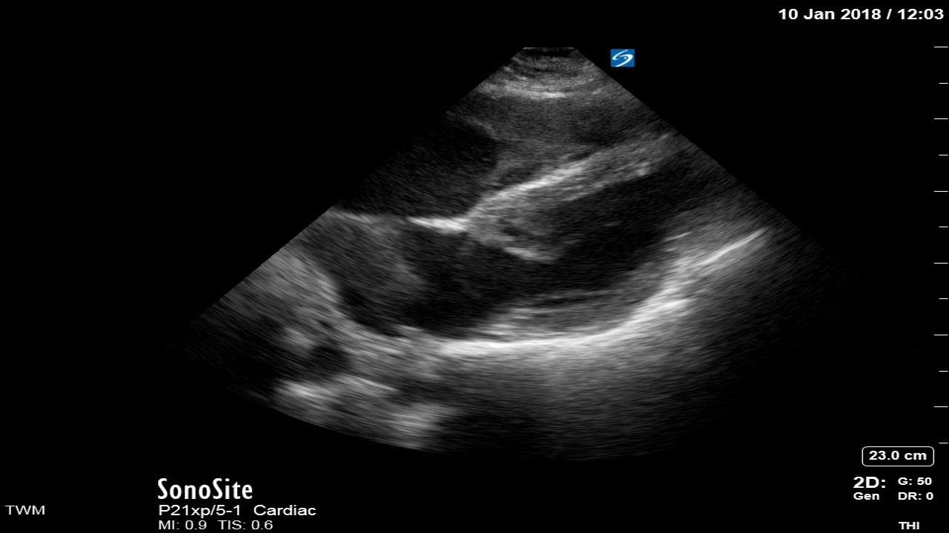
http://www.em-wsht.org/ultrasound-cases/2018/1/16/pocus-in-cardiac-arrest-ventricular-standstill

Appendix C: Facilitator Cheat Sheet & Debriefing Tips

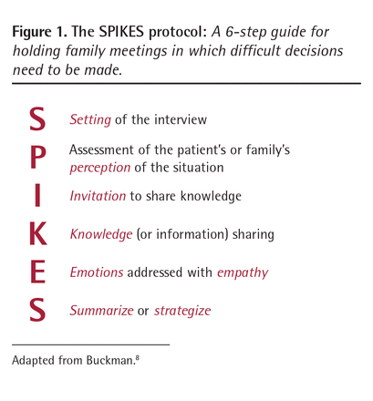
Key moments:
- Recognition of PEA and management according to ACLS
- Proper Role Assignment
- Appropriate teamwork and communication among team mates during cardiac arrest
- Decision to terminate resuscitation
- Communicating with the wife regarding the patient’s prognosis and decision to terminate further resuscitative effort.
- Invitation to attend resuscitation prior to termination.

Sample questions for debriefing:
- Have you been present at resuscitations that have not been successful? How did you feel about them?
- How do we decide to terminate resuscitation? What are poor prognostic factors for ROSC?
- What are the key steps in the PEA arrest algorithm?
- How did you feel interacting with the family member? What worked well? Did you have an approach?
- What are some tools to help navigate conflict regarding treatment decisions within the medical team?
- What are your thoughts about having family members present during cardiac arrests?
Debriefing points:
Objective 1: Demonstrate appropriate management of a PEA arrest (high quality CPR, reversible causes)
- Quality of CPR, appropriate meds, intubation (but BVM ventilation okay if team chooses not to intubate), utilization of bedside ultrasound (RUSH exam), assessment of H’s and T’s (fluid bolus, may give bicarb, assess for pneumothorax, checks glucose, checks K)
Objective 2: Recognize when further resuscitation efforts are futile and implement termination of resuscitation
- Assess code status, living will for the patient
- Predicts difficult resuscitation with no ROSC, declining ETCO2, prolonged down time as indicators of futility
- Elicits team consensus on pronouncement
- Invites family member in for resuscitation; can debate pros and cons
Objective 3: Communicate clearly with the team during a cardiac arrest
- Designates team leader and other team roles
- Use of closed loop communication during arrest, team members speak up if they have concerns using SBAR (Situation, Background, Assessment, Recommendation):
- Delegation of actions: if wife comes in during resuscitation, team member is delegated to updating wife with the clinical status of the patient and what she is currently witnessing. Ideally this team member +/- SW will stay with wife for the remainder of scenario.
Objective 4: Communicate with family/wife in a compassionate and effective way about the death of the patient
- SPIKES protocol or alternate approach
- Appropriate content – explains the facts clearly, no use of euphemisms or medical jargons.
- Non-verbal communication cues with family member – tone of voice, eye contact.

References

1. Limehouse WE et al. A model for ED end-of-life communications after acute devastating events--part II: moving from resuscitative to end-of-life or palliative treatment. Acad Emerg Med. 2012 Nov;19(11):1300-8.
2. Morrison LJ et al. Implementation trial of the basic life support termination of resuscitation rule: reducing the transport of futile out-of-hospital cardiac arrests. Resuscitation. 2014 Apr;85(4):486-91.
3. Joshi R. Family meetings: An essential component of comprehensive palliative care. Canadian Family Physician June 2013, 59(6)637-639.

